Anonymous Application for PhD study in Astronomy at Durham University
This form supports our anonymous short-listing process. Please complete it with 11pt font, deleting all italic text in any white or blue box. E-mail this one page as a pdf to physics.postgraduate@durham.ac.uk.

Initials: (initials only please) | E.g JMW if your name is Jo Mariana Williams

Project Selection: A minimum of 2 and a maximum of 4 supervisors/projects that you wish to be considered for and included in the Astronomy PhD project booklet.
E.g. | E.g.
E.g. | E.g.

Degree programme, Year (to be) awarded, annual average Grade in % (or converted to %) for the last 2 years of completed study: Add a * if you wish us to consider any extenuating circumstances, as described in your non-anonymised PG application. | E.g Astrophysics at Uppsala University (MPhys -2023), 52%* (2022), 78% (2021)

Research Experience: List up to 3 titles of research projects that you have undertaken. Was this individual or group research (state group size), part of your undergraduate programme or an extra-curriculum project? List funding bodies for projects, if applicable. Please do not list project supervisors, nor host institutions. If you have submitted/published any papers - tell us here – and include a link to the paper in your non-anonymised PG application form. Absence of publications is no concern, as it is very rare at this career stage!
E.g “The AGN-Galaxy host connection” - 3rd year research project (group work with 3 other students)
E.g “The intrinsic correlation of galaxy shapes” - on-going MPhys project.
E.g “MUSE observations of NGC 3115” - department funded summer project – paper submitted as 2nd co-author.

Research Summary: Tell us more about one of these projects - keeping this whole application form within one page. Please mention any relevant skills that you developed when undertaking this project. We would really love to see a figure (or maybe equation) you made, if you have one that you can discuss. If you decide to edit the form using “Make a Copy” - you can update the figure using a right click, followed by “Replace Image”.
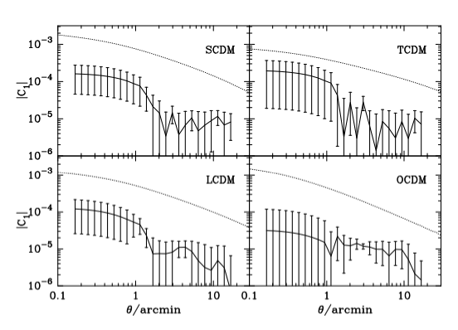
My measurement of the correlation of galaxy shapes with bootstrap errors as a function of their separation on the sky for four different cosmological models. I analysed a suite of N-body simulations and compared my measurements to the expected signal from weak gravitational lensing (shown as a dashed line in each panel). This research improved my python coding skills and broadened my knowledge of observational cosmology.

Fee status: (please answer Home if you are eligible for Home fees; International otherwise) | Home / International (delete as appropriate)

Do not write on this page - you have exceeded the single page limit

Instructions for submission:

- Make a copy of this form for yourself to edit. 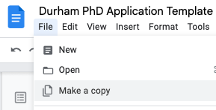
- Fill in the form either as a google doc or word doc.
- Remember that you can delete any text in italics in the blue and the white boxes, giving you more space to describe your research project, which could be up to half a page long.
- Export the single page form as a PDF – remember that the pdf should be at most 1 page: any longer and you have to shorten your descriptions to fit the page limit.
- Rename the file on your computer in the format
[your banner ID]_[initials].pdf
- Email the PDF to physics.postgraduate@durham.ac.uk
- If you have any questions on how to fill it in or how to find e.g your banner ID, please contact physics.postgraduate@durham.ac.uk to ensure any query you might have remains anonymous to the selection panel.

This template is based on the one in use by The University of Edinburgh in their anonymised PhD application process.

